FACE EMOTION RECOGNITION USING FACE-API

Divya Sri G #1, Humsika R#2, Keerthana Thilagam D#3, Dr. R. Josephine Leela#4

*#Computer Science and Engineering Department, Panimalar Engineering College  
Chennai, India*

1divyasri.gopi28@gmail.com

[2](mailto:2third.author@first-third.edu)[rhumsika@gmail.com](mailto:2third.author@first-third.edu)

[3keerthanadhanasingh@gmail.com](mailto:3keerthanadhanasingh@gmail.com)

4pitleela2016@gmail.com

***Abstract*— Emotions are a powerful tool in communication and one way that humans show their emotions is through their facial expressions. One of the challenging and powerful tasks in social communications is facial expression recognition, as in non-verbal communication, facial expressions are key. In the field of Artificial Intelligence, Facial Expression Recognition (FER) is an active research area, with several recent studies using Convolutional Neural Networks (CNNs). Emotion detection research has been widely utilized in many different fields including Human-Computer Interaction and Ubiquitous Computing. Facial Emotion Recognition is a technology which is used to analyze our facial expressions from videos or images in order to reveal information on one's emotional state. Face detection is one of the most common applications of Artificial Intelligence. There are many attempts to make an automatic facial expression analysis tool as it has application in many different fields such as robotics, medicine, driving assist systems, and lie detector. It is the task of classifying facial emotions into several categories such as anger, fear, surprise, sadness, disgust, neutral and happiness. We will be implementing JavaScript API (face-api.js) introduced by Vincent Mühler for detecting facial emotions on the browser.**

***Keywords***— **Face detection, Facial emotion recognition, face-API, Convolutional Neural Networks (CNNs), Artificial Intelligence**

1. Introduction

The research on facial emotion recognition has become extensive these recent years. Facial recognition system is a technology that is capable of matching an individual’s face from a digital image or a video frame against a database of faces, usually employed for the authentication of users ID, and also by measuring facial features from a given image.  It is mostly used for security purposes, widely used in the range of applications for government and enterprises use. The aim of facial emotion recognition model is to help us in identifying the state of human emotion (example: neutral, happy, sad, surprise, anger, disgust) based upon the facial images. The challenge on facial emotion recognition is to automatically recognize facial emotion state with high accuracy.

Generally, it involves three stages. They are, (i) Face Detection, (ii) Feature Extraction and (iii) Emotion Classification. In the first stage, it will locate user’s face through webcam or from images and will be shown as face bounding boxes. At the second stage, after detecting the position user’s face, facial features will be extracted as 68 face landmark points of that individual (i.e., eyes, brows, mouth, nose, jawline). After getting the required facial features in the final stage, the model should be trained to generate labels for the respective emotions based on the trained data.

Face-API is a JavaScript API built on top of Tensorflow core API which implements several CNNs (Convolutional Neural Networks) to solve face detection, face recognition and face landmark detection, optimized for the web and for mobile devices that is commonly used for face detection and face recognition via browser. In this paper, we will be using Face-api.js developed by Vincent Mühler which is a Javascript library that helps us to recognize emotions for multiple individuals along with age and gender through browser by four pre-trained models.

1. LITERATURE SURVEY

K.Lekdioui [1], proposed a new facial decomposition for basic emotion states recognition. Based on facial landmarks detected by IntraFace algorithm, seven regions of interest (ROI), corresponding to the main components of face, are first extracted to represent face image. A pre-processing stage is then applied on these ROIs for resizing and partitioning them into blocks, before performing feature extraction to build face feature descriptor. Finally, a multiclass SVM classifier is utilized to infer emotion state. A comprehensive experimental study, using different local features, is carried out to compare the proposed method to two state of the art methods; one is based on whole face as a single ROI and the other one uses facial decomposition with six ROIs.

S. K. Khanal et al [2], performed analysis of two famous emotion recognition APIs under the facial images of various poses. The experiments were done with the public dataset which is KDEF dataset containing 980 images of each type of five poses fullleft, half-left, straight, half-right, and full-right with the seven emotions (Anger, Afraid, Disgust, Happiness, Neutral, Sadness, Surprise). It has been discovered that overall recognition accuracy is best in Microsoft Azure for straight images, whereas the face detection capability is better in Google. The Microsoft Azure did not detect almost any of the images with full left and full right profile, but Google detected almost all of them. The Microsoft API presents an average true positive value up to 60%, whereas Google presents the maximum true positive value 45.25%.

M. Shamim Hossain [3], In this paper an emotion recognition system for mobile applications has been proposed. The Bandlet transform is applied to some selective frames, which are extracted from the video, to give some sub band images. Local binary patterns (LBP) histogram is calculated from the sub band images. This histogram describes the features of the frames. The Bandlet transform and the LBP are used as features, which are then selected by the KW feature selection method. The GMM based classifier is applied to recognize the emotions. Two publicly available datasets are used (Canade-Kohn (CK) and the Japanese female facial expression (JAFFE)).

Renuka S. Deshmukh [4], In this paper, they have discussed various attributes, methods and emotional labels that are considered by various emotion API system and also gives an overview of the databases available for inferring emotion through human facial features. The facial expression detection tools lump human emotion that can be categorized as Joy, Sadness, Anger, Fear, Surprise, Contempt, and Disgust. With this facial emotion detection, algorithms detect faces within a photo or video. There are various tools developed for emotion detection and recognition: Microsoft cognitive services, Kairos, Eyris EmoVu, Sky biometric application, Affectiva, Emotient etc. This paper gives a brief introduction towards various tools and description in terms of their features, the approach or methods through which they are implemented.

Ma Xiaoxi, Lin Weisi [5], In this paper, they have implemented several learning methods: Support Vector Machine(SVM)and Deep Boltzmann Machine (DBM) for facial emotion recognition, which are all excellent methods in general and the aim is to construct the prediction system which is most suitable to the challenge. Comparing the experiment results of different prediction systems, the best performance of Occurrence Detection of AUs is obtained by emotional facial classification system with SVM. This paper mainly focuses on the implementation and comparison of different learning methods.

1. Proposed model

We have a proposed a new model by making use of four pre-trained models for facial emotion recognition. Four models that are applied for face detection and face recognition in the browser are: Face Detection Model (Tiny Face Detector), 68 Point Face Landmark Detection Models, Face Expression Recognition Model, Age and Gender. These pre-trained models use CNN (Convolutional Neural Networks) Algorithm which are a class of neural network that allow greater extraction of features from captured videos. It takes video data, trains the model, and then classifies the features automatically for healthier classification. This is used in many applications like image recognition, face recognition, and video analysis.

MODULE DESIGN SPECIFICATION:

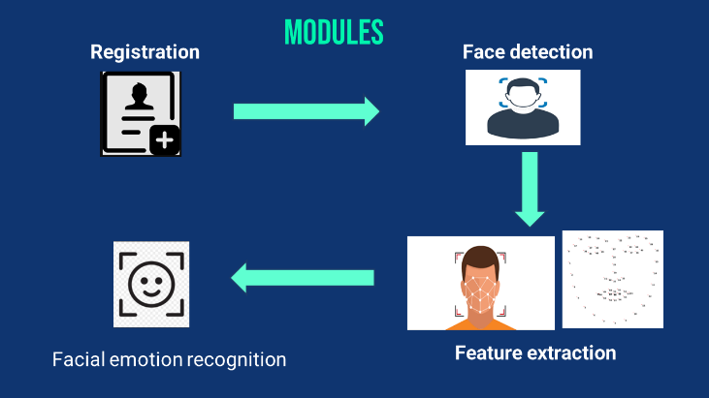

1. *Registration*

The user can register/login to the system by giving their necessary details. The user credentials will be validated by the system.

1. *Face Detection*

This module helps us to identify and extract parts of the user’s face from videos or image should be focused on. Using the Tiny Face Detector model, the user’s face will be located and returned as bounding boxes. This model has been trained to predict bounding boxes of each individual’s face.

1. *Feature Extraction*

For extracting the facial feature, we are making use of 68 Point Face Landmark model. This pre-trained landmark detector identifies 68 points ((x, y) coordinates) in an individual’s face. These points localize the region around the user’s eyes, brows, nose, mouth, chin and jaw.

1. *Emotion Recognition*

Emotion recognition is the task to analyse, interpret and classify human emotion through the analysis of facial features. This module uses a pre-trained face expression model to classify seven emotions (happy, sad, angry, disgusted, neutral, surprised, fear) along with estimating age and gender using age and gender model.

MODEL DESCRIPTION:

We are making use of four pre-trained models for face detection and face expression recognition along with age and gender. The four models are described in detail in the following section,

FACE DETECTION MODEL:

1. *Tiny Face detector*

It is a real-time face detector which is very efficient, smaller and less resource consuming when compared to SSD Mobile net V1 face detector. This model is mobile and web friendly. It has been trained to predict bounding boxes that covers the entire facial feature points on a custom dataset of ⁓ 14k images. Moreover, we can also compute the Euclidean distance between two face descriptors in order to determine similarity between two faces based on a certain threshold value (for 150 x 150 sized face images 0.6 is a good threshold value).

1. *68point face landmark detection model*

This model implements a lightweight 68-point face landmark detector with better accuracy at faster rate. It has been trained used to track and locate the 68 facial points in a person’s face(eyes, eyebrows, nose, mouth, jaw and chin) on a dataset of ~35k face images with 68 face landmark points.

1. *Facial Expression Recognition*

For Facial expression recognition is the task of classifying the expressions on face images into various categories such as anger, fear, surprise, sadness, happiness and so on.

1. *Age and Gender Recognition Model*

Emotion recognition is the task to analyse, interpret and classify human emotion through the analysis of facial features. This module uses a pre-trained face expression model to classify seven emotions (happy, sad, angry, disgusted, neutral, surprised, fear) along with estimating age and gender using age and gender model

1. system architecture

Firstly, the webcam captures the user’s face which is then used to detect the face, this system is also able to detect multiple faces

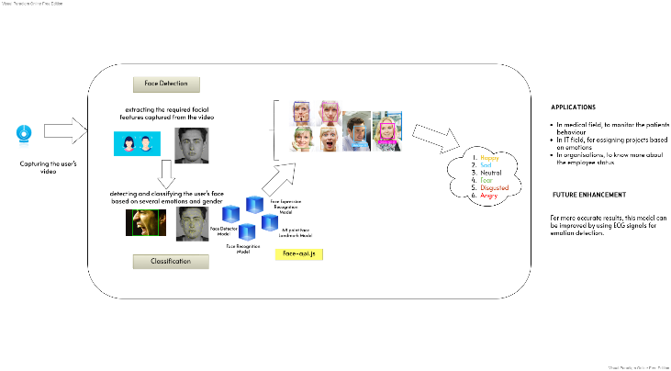

Secondly, the facial features are extracted using the pre-trained land mark detection model. Thirdly, using the face expression recognition model the emotions of each individual is detected and displayed along with the age and gender using the age and gender recognition model.

1. results and discussion

Facial emotion recognition systems are laying the foundation for a variety of applications that could be beneficial to the world. The simplicity of our project is one of its best features. Our project is implemented using JavaScript and can be accessed directly using our preferred browser. There are numerous benefits to using a simple emotion detection and identification model. We will be able to receive immediate feedback and results of people's emotion alongside with their gender and age, which will be beneficial for marketing, generating suggestions, and so on.

1. Conclusions and future enhancement

For Future Enhancement, the proposed work can be enhanced by increasing the number of possible expressions other than anger, fear, disgust, joy, surprise, sadness, and neutral. Secondly, ECG signals can be used to detect emotions, resulting in higher accuracy.

Our project can be utilized in different sectors like in medical field to monitor patient behavior, IT field to assign tasks based on emotions, and in any organization to learn more about employee status. Various other unique operations and uses are still to be seen using facial expression detection technology.  This system can become more powerful and effective in dispatches.. We propose a new way to boost the performance of the APIs. Also, we show APIs still suffer in recognizing emotions in real life environments. We hope our work will provide an insight into the future works needed to be done in this arena to make these systems practical and perform well in real life scenario.

Acknowledgment

We would like to express my special thanks of gratitude to our HOD of Computer science department Dr. S.MURUGAVALLI and our guide Dr.R.JOSEPHINE LEELA as well as our principal who gave us the golden opportunity to do this wonderful project on the topic FACIAL EMOTION DETECTION USING FACE-API, which also helped us in doing a lot of Research and we came to know about so many new things. We are really thankful to them.

References

1. Khadija Lekdioui, Yassine Ruichek, Rochdi Messoussi, Youness Chaabi, Raja Touahni, YEAR: May, 2017 “Facial Expression Recognition Using Face-Regions”, 2017 International Conference on Advanced Technologies for Signal and Image Processing (ATSIP), DOI: 10.1109/ATSIP.2017.8075517
2. S. R. Khanal, J. Barroso, N. Lopes, J. Sampaio, and V. Filipe. YEAR : June 20-22, 2018, “Performance analysis of Microsoft’s and Google’s Emotion Recognition API using pose-invariant faces”. In Proceedings of Software Development and Technologies for Enhancing Accessibility and Fighting Info-exclusion – Aristotle University of Thessaloniki, Greece, June 20-22, 2018 (DSAI 2018) https://doi.org/10.1145/3218585.3224223
3. M.Shamim Hossain and Ghulam Muhammad, YEAR: February 2017, “An Emotion Recognition System for Mobile Applications”, Institute of Electrical and Electronics Engineering (IEEE), DOI: 10.1109/ACCESS.2017.2672829.
4. M.Mohammadpour, H. Khaliliardali, S. M. R. Hashemi and M. M. AlyanNezhadi, YEAR: February 2017 "Facial emotion recognition using deep convolutional networks,"2017 IEEE 4th International Conference on Knowledge-Based Engineering and Innovation (KBEI), 2017, pp. 0017-0021, doi: 10.1109/KBEI.2017.8324974.
5. Renuka S. Deshmukh and Prof. Vandana Jagtap,YEAR: June,2017 “A Survey: Software API and Database for Emotion Recognition”, International Conference on Intelligent Computing and Control Systems (ICICCS), DOI: 10.1109/ICCONS.2017.82507273.
6. M.Xiaoxi, L. Weisi, H. Dongyan, D. Minghui and H. Li, "Facial emotion recognition," YEAR: August 2017,IEEE 2nd International Conference on Signal and Image Processing (ICSIP), 2017, pp. 77-81, doi: 10.1109/SIPROCESS.2017.8124509
7. Yang-Yen Ou, Bo-Hao Su, Shih-Pang Tseng, Liu-Yi-Cheng Hsu, Jhing-Fa Wang and Ta-Wen Kuan, YEAR: October 2018, “Efficient Emotion Recognition based on Hybrid Emotion Recognition Neural Network”, International Conference on Orange Technologies(ICOT), DOI: 10.1109/ICOT.2018.87059034.
8. M. Abdullah, M. Ahmad and D. Han ,YEAR : Jan 2020,"Facial Expression Recognition in Videos: An CNN-LSTM based Model for Video Classification," 2020 International Conference on Electronics, Information, and Communication (ICEIC), 2020, pp. 1-3, doi: 10.1109/ICEIC49074.2020.9051332
9. S. Manna, S. Ghildiyal and K. Bhimani, YEAR : June,2020"Face Recognition from Video using Deep Learning," 2020 5th International Conference on Communication and Electronics Systems (ICCES), 2020, pp. 1101-1106, doi: 10.1109/ICCES48766.2020.9137927.
10. Dhand, Geetika and Beri, Tanisha and Sobti, Tanvi and Angrish, Vidhi, “Music Recommendation Using Sentiment Analysis from Facial Recognition”,(February 22, 2022).Available at SSRN: https://ssrn.com/abstract=4041049 or http://dx.doi.org/10.2139/ssrn.4041049
11. D. Ram Kiran, K. Vinay Kumar, T. Kalyan, K. Ch. Kavya, K. Sarat Kumar, YEAR: July 2022, “Facial Expression Detection using Artificial Intelligence”, International Journal of Recent Technology and Engineering (IJRTE), DOI: https://doi.org/10.35940/ijrte.2277-38785
12. S. R. Khanal, J. Barroso, N. Lopes, J. Sampaio, and V. Filipe. YEAR : June 20-22, 2018, “Performance analysis of Microsoft’s and Google’s Emotion Recognition API using pose-invariant faces”. In Proceedings of Software Development and Technologies for Enhancing Accessibility and Fighting Info-exclusion – Aristotle University of Thessaloniki, Greece, June 20-22, 2018 (DSAI 2018) https://doi.org/10.1145/3218585.3224223